**College Athletes in Mecklenburg County**

**Grind Their Way Into Endorsement Deals**

*By Shannon Kingston and Kayla McDuffie*

*Queens University News Service*

*Nov. 17, 2022*

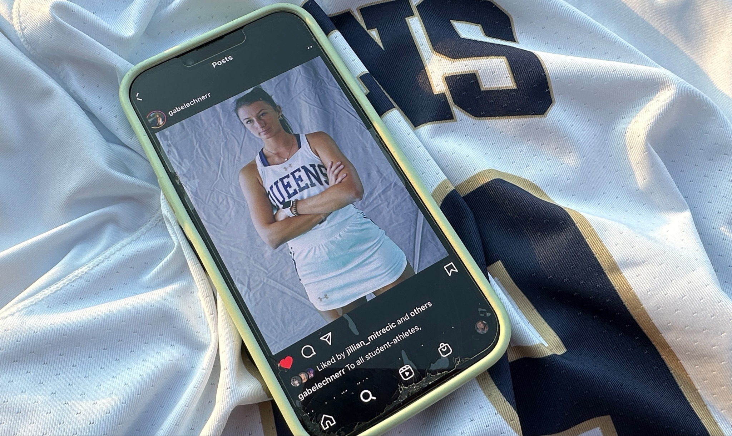

*Athlete Gabe Lechner of Queens University of Charlotte uses her Instagram account to promote Liquid IV, a sports beverage company. Queens University News Service photo by Shannon Kingston.*

About 2,100 athletes compete for four universities in Mecklenburg County, and much of what they eat, when they wake up, what they wear to practice, and when they exercise is decided by somebody else. But they’re 17 months into a new world of endorsement deals allowed by the NCAA, and now they get to tell their own story.

[Names, image and likeness deals](https://www.ncaa.org/news/2021/6/30/ncaa-adopts-interim-name-image-and-likeness-policy.aspx) are often associated with athletes making millions at large universities, like [gymnast Olivia Dunne of Louisiana State University](https://www.nytimes.com/2022/11/08/sports/ncaabasketball/olivia-dunne-haley-jones-endorsements.html). But sports agents say NIL deals are completely within the reach of athletes from smaller or lesser-known universities.

Athletes and agents use the word “grind” to describe their work ethic on and off the field, and the same concept applies to NIL deals.

“It really depends on your grind, your drive and your wanting to do it at a smaller institution, versus maybe a larger institution,” said Julius Scott, compliance director at Queens University of Charlotte. “There are some advantages depending on students’ locale. I think there are endless opportunities in Charlotte to grow and promote their brand.”

Doug Hicks is a partner at [Triumph NIL,](https://www.triumphnil.com) an agency in Blacksburg, Virginia, that matches student athletes with companies. Triumph’s online platform competes with similar apps used by student athletes at UNC Charlotte and Davidson College. But even if smaller universities don’t yet provide platforms to connect athletes with brands, Hicks said, students can seek help from sports agencies or reach out directly to companies that align with their interests.

**The University’s Brand, the Athlete’s Brand, and Gender Differences**

Athletes now have the autonomy to market themselves separately from their university, which presents a remarkable new opportunity, Hicks said. For many athletes, the value of these deals is the educational process and the network, not the money.

“They still have a network, business acumen, and they’re still building something that makes them a more valuable and interesting applicant when they go into the work world,” Hicks said.

Beyond performance, companies look for an athlete’s ability to brand and connect with sponsors and fans, said Ken Neal, president of Alliance Sports Management in Davidson. For many athletes at small universities, this means social media promotions. “You have to have some passion to do it because the client in this case is going to expect you to push their product on your social media platform and be out there,” Neal said.

Differences in opportunities based on gender may be beginning to show up at this level, Neal said. A top male basketball player at Davidson might be a good fit for a car dealership deal, he said, and current perceptions and metrics suggest that female athletes are more social-media savvy, self-starters, and brand-aware. He pointed to [Haley and Hanna Cavinder,](https://theathletic.com/3779314/2022/11/10/cavinder-twins-miami-nil/) twin basketball players at the University of Miami, who are making more than $1 million in NIL.

**Word-of-Mouth Promotion and Discount Links**

Some deals capitalize on word-of-mouth promotion on college campuses. Jakob Villasista, a lacrosse player at Queens, recently signed a deal with Rhoback, an online sports apparel shop. Villasista shares his custom discount links with other students and receives a commission on purchases they make. He is not required to post on social media, but his profit depends on his ability to network, and the company provides competitive incentives for bringing in more customers.

Villasista encourages athletes to step out of their comfort zone to seek deals, even if they get turned down. “If you show that you’re doing it on your own, I think companies may appreciate that. And you may not have to go to national brands. You can look around the Charlotte area,” he said.

Before the [NCAA’s NIL ruling](https://www.nytimes.com/2021/06/30/sports/ncaabasketball/ncaa-nil-rules.html) in June 2021, universities could use the names, images, and likenesses of student athletes to generate revenue, but student athletes were not allowed to pursue these opportunities. The institutions also decided how these athletes were marketed.

Now student athletes control their own marketing power. If a company’s target market aligns with an athlete’s identity, or includes a cause they are passionate about, Hicks said, that creates a better story and relationship for better results.

In his plan for the future of his own brand, Villasista wants to build a partnership with a protein bar brand that uses nut-free production facilities. He has a peanut allergy, realizes this is an uncommon product category, and wants to get involved.

**Building a Business Network**

Research released in March 2022 by Junior Achievement USA indicates that nationally, young people are losing interest in traditional jobs and want to [work for themselves](https://www.cnbc.com/2022/03/03/60percent-of-teens-want-to-launch-businesses-instead-of-working-regular-jobs.html). NIL deals are one way student athletes can learn essential business skills, independence and entrepreneurship – assets that will help them when their athletic career ends.

“It's a good way to be involved with companies,” said Gabe Lechner, who plays field hockey for Queens and has had an NIL deal for two years with [Liquid IV](https://www.liquid-iv.com), an electrolyte sports beverage company. She points to the numerous [NIL deals of Erin Matson,](https://www.hrotoday.com/news/personify-partners-with-erin-matson-three-time-ncaa-womens-field-hockey-champion-in-name-image-and-likeness-agreement/) a member of the U.S. national field hockey team and the team at UNC-Chapel Hill. Matson’s NIL deals range from human resources recruiting to a [Chapel Hill tire store.](https://www.chapelhilltire.com/our-community-erin-matson/) “It's a good way to get connections.”

*Shannon Kingston of Longmeadow, Massachusetts, and Kayla McDuffie of Winterville, North Carolina, are students in the James L. Knight School of Communication at Queens University of Charlotte, which provides the news service in support of community news. Kingston plays lacrosse for Queens, and McDuffie plays volleyball.*